m a g a z i n e a l t e r o l o g y

a n a d v e n t u r e i n c o l l a g e & a s s e m b l a g e w i t h C l a u d i n e H e l l m u t h

This is the supply list for the magazine alterology class - we'll be creating Polaroid-transfer-looking images with household materials and old magazines!

NOTICE! NOTICE! This class uses NON TOXIC household cleaning materials: cleaners and solvents - all are non toxic but a little stinky. If you are extremely sensitive to the smell of these materials you probably should not take this class.

I will provide the household products to alter the magazine pages with, and a few paints and collage supplies etc., however please bring a few of your favorite collage items things to work with for this class, we will create completed collages with our altered magazines. Please remember we plan to work in a small scale. So think no larger than about 8x10.

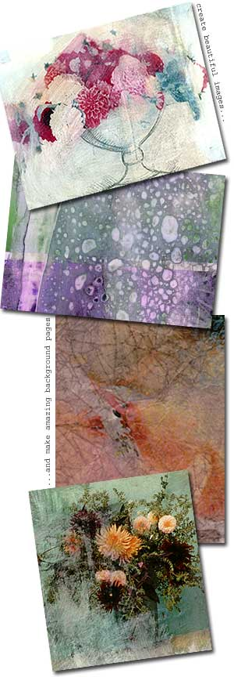
supply list
- Acrylic paints, 2 to 4 tubes of colors. We will also use these to further alter our magazine pages
- At least 5 used magazines for yourself + 2 magazines to add to the "community" magazine pile for everyone to share. Please bring at least one National Geographic (circa 1990-present). Other than that, any type of magazines are good for these techniques, TIME, Newsweek, space and history magazine are good too. Magazines with matte pages or very thick pages don’t work well, you’ll need pages that are glossy.
- Anything you would like to use as your artmaking surface: pre-stretched canvas, canvas board, cigar boxes, altoid tins, hard cover journals or any other support surface you would like. If time allows we will create completed collages with our altered magazines.If you are traveling from a distance I suggest you bring a pad of canvas paper (I like to use Fredrix brand), you can find it in the aisle of the craft or art supply store where they keep the sketchpads. One pad of canvas paper has about 10 sheets in it.
- Paint brushes about 2 or 3, any size. c
- Xacto knife or scissors
- Some type of glue. I like to use gel medium to glue with, but feel free to bring whatever you have
- A variety (about 10-15) of paper collage supplies & small objects
- Heat gun or hairdryer. You don’t have to bring this if you don’t want to. I will have one for everyone to share.
- Rubber kitchen gloves. If you have nice nails or sensitive skin you will want to wear gloves to protect them.

If you have any questions about the supply list, please email me at claudine@collageartist.com. This list is not set in stone. Please bring as many of the required items as you can -- it will make the workshop much more enjoyable for you.

